ALCHEMY PVT TUITIONS

CLASS : XIIth SUBJECT : CHEMISTRY
DATE : 26/09/2022 DPP NO. : 4
Topic :-HALOALKANES AND HALOARENES

1. t-butyl chloride preferably undergo hydrolysis by
a) $S_{N}1$mechanism
b) $S_{N}2$ mechanism
c) Any of (a) and (b)
d) None of the above

2. Which statement is wrong about chloroform?
a) Chloroform is used as anaesthetic
b) Chloroform has distorted tetrahedral shape
c) Chloroform is used as a solvent
d) Chloroform has $sp^{2}$-hybridised carbon atom

3. When ${CCl}_{4}$ is boiled with KOH, the product formed is:
a) Formic acid b) Methyl alcohol c) Formaldehyde d) Carbon dioxide

4. Which set of reagents will produce freon$({CCl}_{2}F_{2})$ ?
a) $C+F_{2}+{Cl}_{2}$ ⟶ b) ${CH}_{3}Cl+F_{2}$ ⟶ c) ${CCl}_{4}+HF {SbCl}_{5}→$ d) ${CCl}_{4}+F_{2}$ ⟶

5. Which of the following will not give positive iodoform test?
a) $CH_{3}CH_{2}CHOHCH_{3}$b) $CH_{3}CH_{2}CH_{2}COCH_{3}$c) $CH_{3}CH_{2}COCH_{2}CH_{3}$d) $CH_{3}COC_{6}H_{5}$

6. Which of the following does not react with benzene in presence of anhydrous ${AlCl}_{3}$?
a) $C_{6}H_{5}Cl$ b) $C_{6}H_{5}{CH}_{2}Cl$ c) ${CH}_{3}Cl$ d) $C_{6}H_{5}{CH}_{2}{CH}_{2}{CH}_{2}Cl$

7. Iodoform is obtained when ethanol is heatd with
a) KI and aq. KOH b) $I_{2}$and aq. KOH c) $I_{2}$/aq. KI d) HI and $HIO_{3}$

8. $n$-propyl bromide reacts with ethanolic KOH to form:
a) Propane b) Propene c) Propyne d) Propyl alcohol

9. Which of the following statements regarding the $S_{N}1$reaction shown by alkyl halide is not correct?
a) The added nucleophile plays no kinetic role in $S_{N}1$reaction.
b) The $S_{N}1$ reaction involves the inversion of configuration of the optically active substrate.
c) The $S_{N}1$ reaction on the chiral starting material ends up with racemization of the product.
d) The more stable the carbocation intermediate the faster the $S_{N}1$ reaction.

10. Pick up the correct statement about alkyl halides:
a) They show H-bonding.
b) They are soluble in water.
c) They are soluble in organic solvents.
d) They do not contain any polar bond.

11. The product of reaction between alcoholic silver nitrite with ethyl bromide is
a) Ethene b) Ethane c) Ethyl nitrile d) Nitro ethane

12. 1-phenyl, 2-chloropropane on treating with alc. KOH gives mainly:
a) 1-phenylpropene
b) 2-phenylpropene
c) 1-phenylpropan-2-ol
d) 1-phenylpropan-1-ol

13. In the reaction,
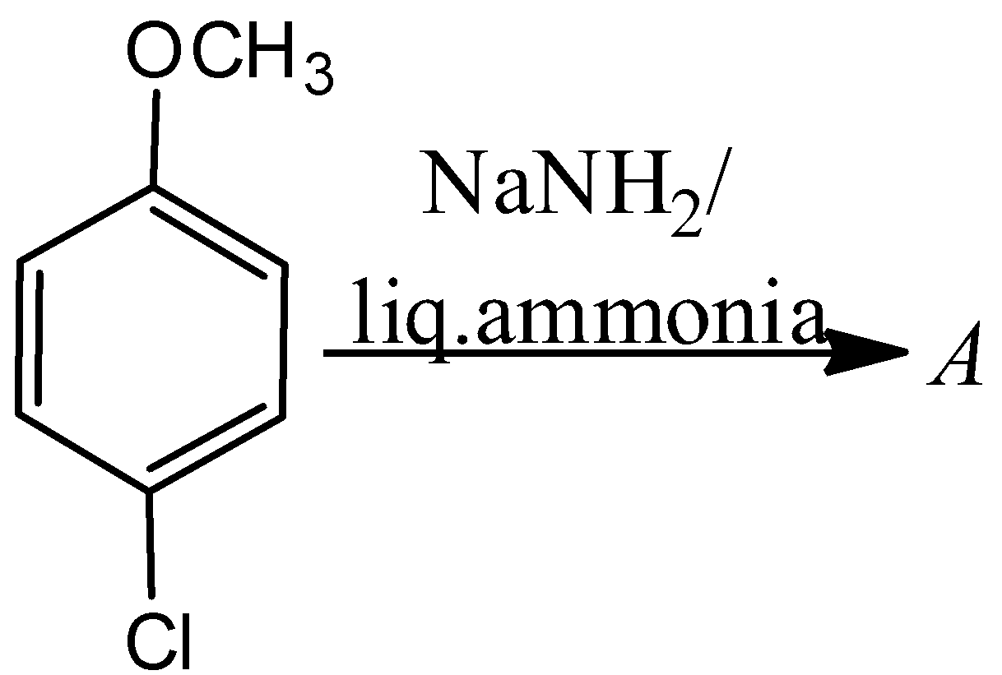
The major product A is
a) 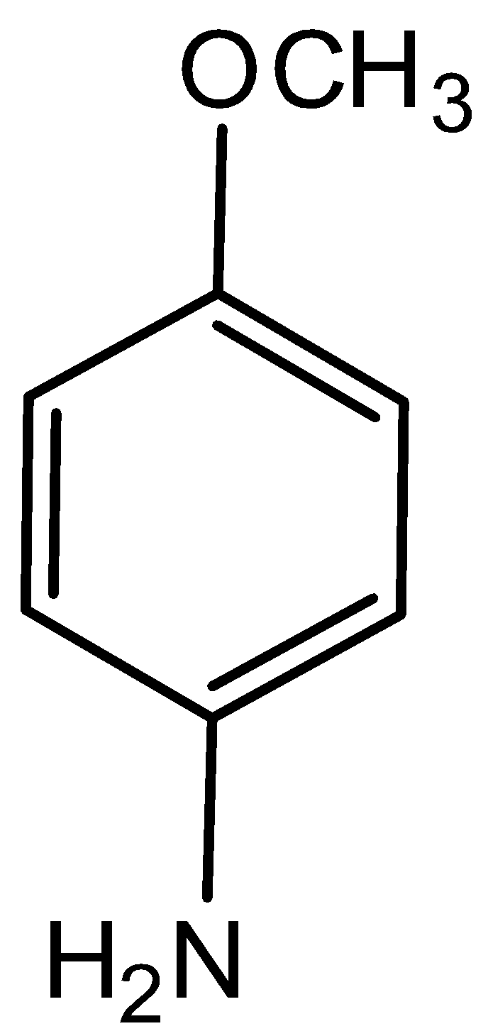 b) 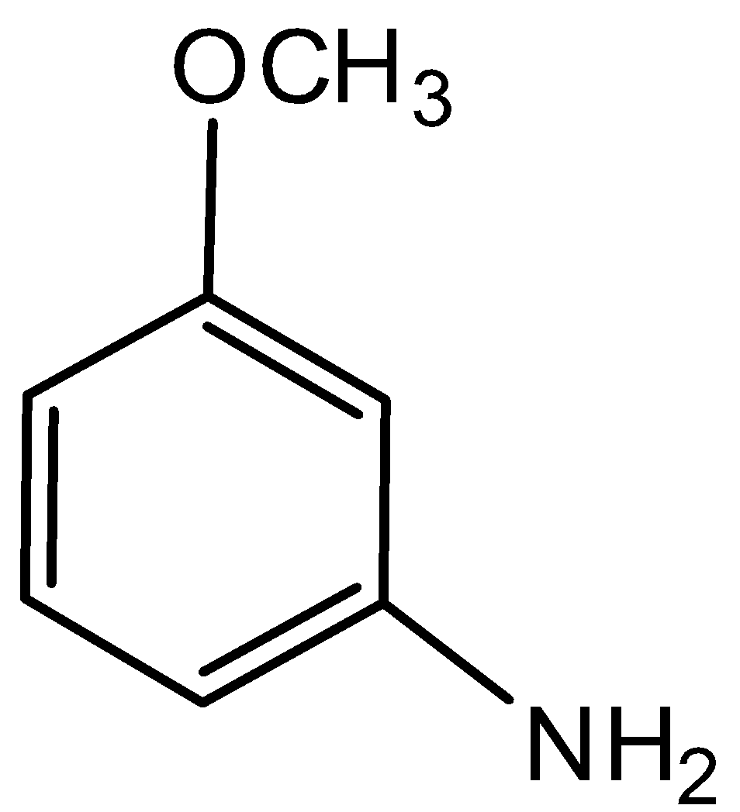 c) 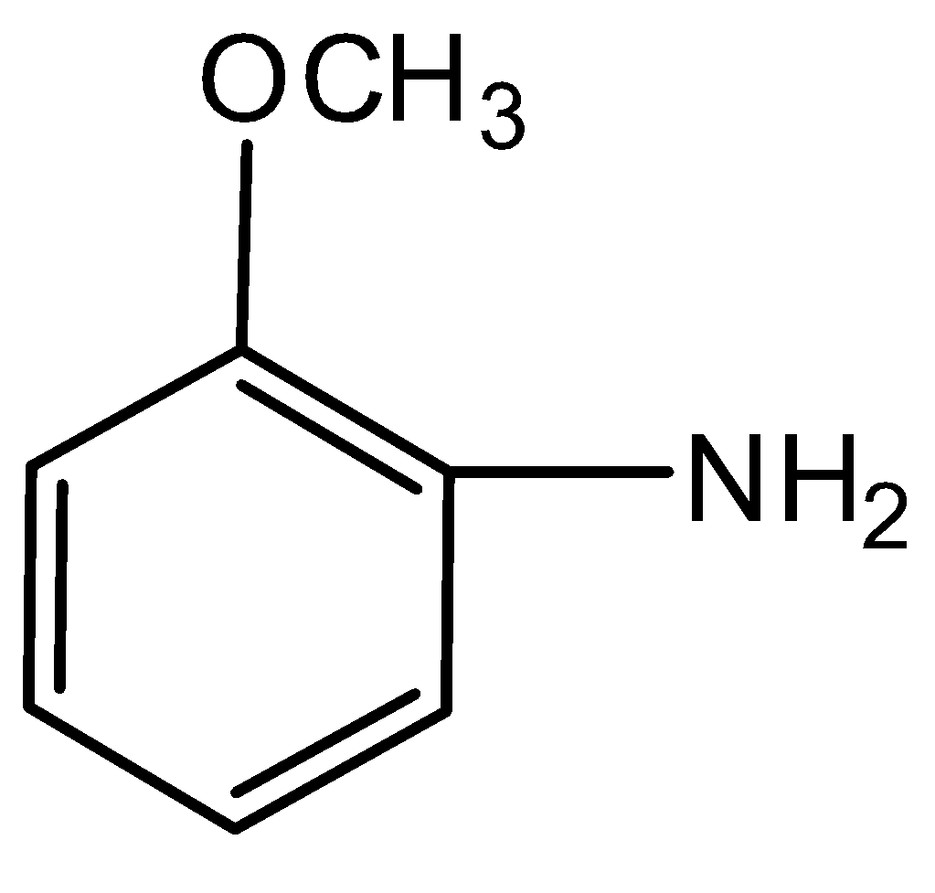 d) 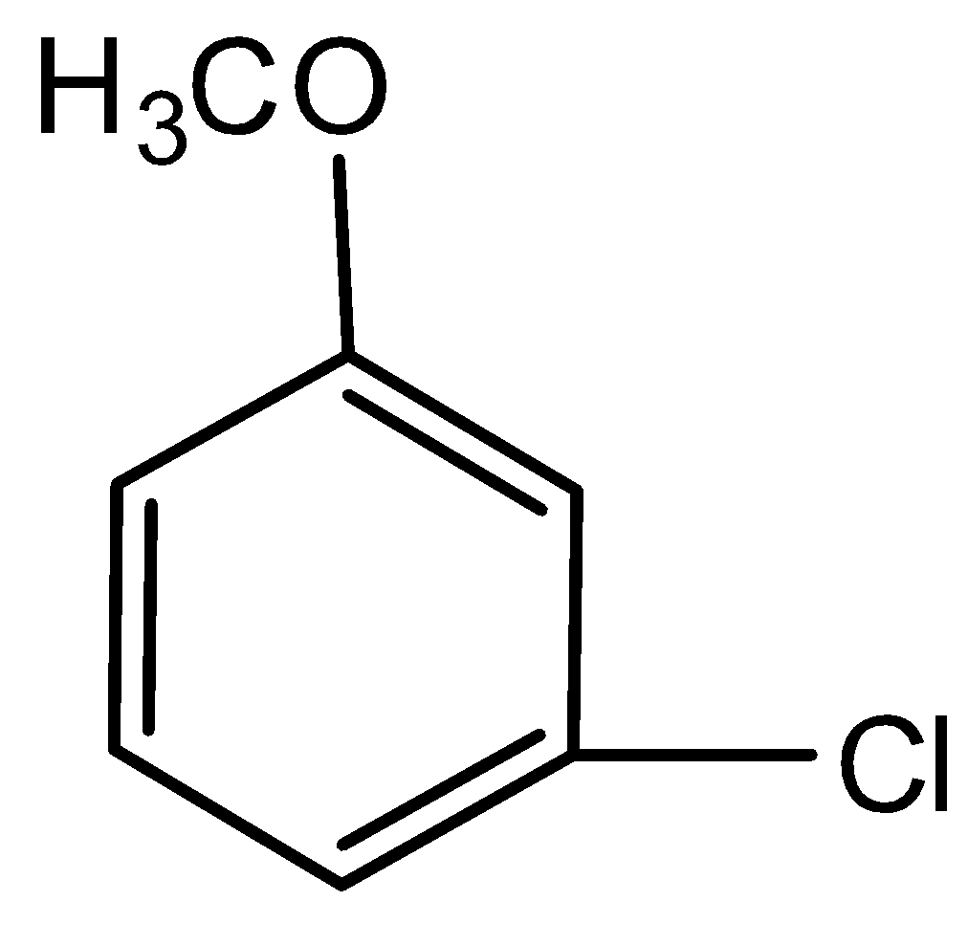

14. ${\left({CH}_{3}\right)}_{3}CMgCl on reaction with D_{2}O gives:$
a) ${\left({CH}_{3}\right)}_{3}$CD b) ${\left({CH}_{3}\right)}_{3}$OD c) ${\left({CD}_{3}\right)}_{3}$CD d) ${\left({CD}_{3}\right)}_{3}$OD

15. Grignard reagent shows addition on:
a) 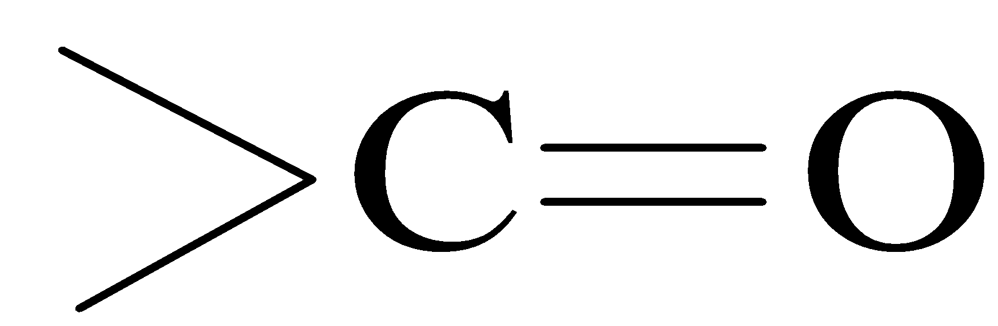 b) —C≡N c) 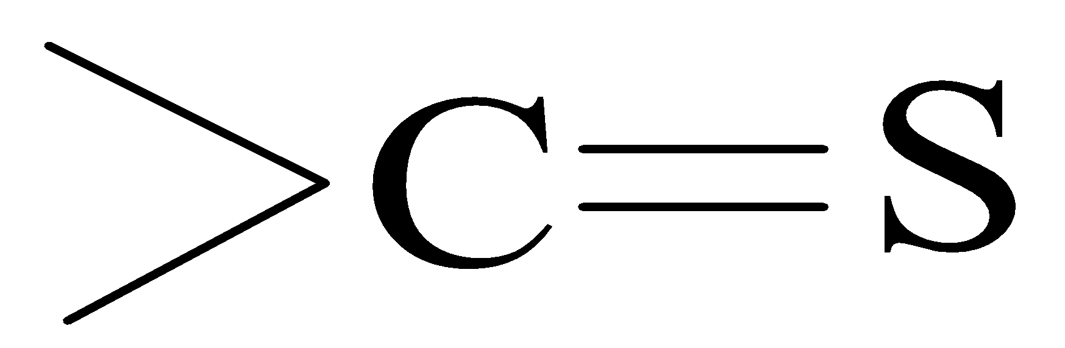 d) All of these

16. When tetrahydrafuran is treated with excess HI, the product formed is
a) 1, 4-diiodobutane b) 1, 4-butanediol
c) 2-iodotetrahydrofuran d) 4-iodo-1-butanol

17. Lodoform can be used in medicine as:
a) Anaesthetic b) Antiseptic c) Analgesic d) Antifebrin

18. A mixture of two organic compounds was treated with sodium metal in ether solution. Isobutane was obtained as a product. The two chlorine compounds are:
a) Methyl chloride and propyl chloride
b) Methyl chloride and ethyl chloride
c) Isopropyl chloride and methyl chloride
d) Isopropyl chloride and ethyl chloride

19. Wurtz’s reaction involves the reduction of alkyl halide with
a) Zn/HCl b) HI c) Zn/Cu couple d) Na in ether

20. In the following sequences of reactions;
$CH_{3}CH_{2}CH_{2}Br KOH\left(alc.\right)→ (A) HBr_{ }→$
$\left(B\right) KOH(aq.)→$ $(C)$ the end product $(C)$ is :
a) Propene
b) Propyne
c) Propan-l-ol
d) Propan-2-ol

